 

**Placement Empowerment Program**

***Cloud Computing and DevOps Centre***

Write the Shell Script to Monitor Logs : Create a script that monitors server logs for errors and alert you

Name: Mathimalar.P Department : ADS



**Introduction and Overview**

Monitoring server logs is a crucial aspect of system administration to ensure the health and security of a system. Logs provide valuable insights into system performance, errors, and potential security threats. A proactive approach to log monitoring helps in identifying issues early, allowing for quick resolutions and minimizing downtime.

**Objective**

The goal of this script is to continuously monitor server logs for errors or anomalies and trigger alerts when predefined conditions are met. By automating log analysis, the script aims to enhance system reliability and security, reducing the manual effort required for log inspection.

.

.

Importance

Real-time log monitoring is essential for maintaining operational efficiency. It enables administrators to detect system failures, unauthorized access attempts, and application malfunctions promptly. This proactive approach minimizes potential damage, ensures compliance with security policies, and helps maintain optimal system performance.

**Step-by-Step Overview**

**Step 1** Create a Folder called logs for Your Logs and Script

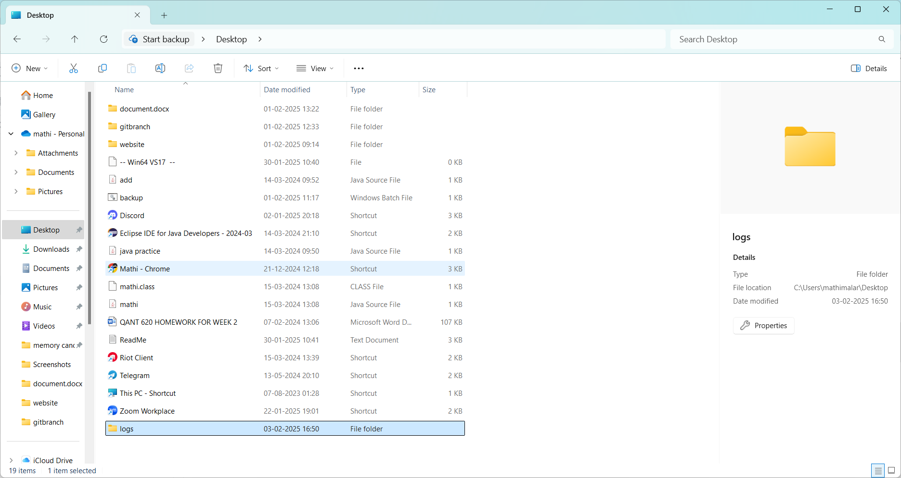

* .

**Step 2**: Open Notepad and Add the following sample text to it and Save the file as mylogfile.log inside the logs folder

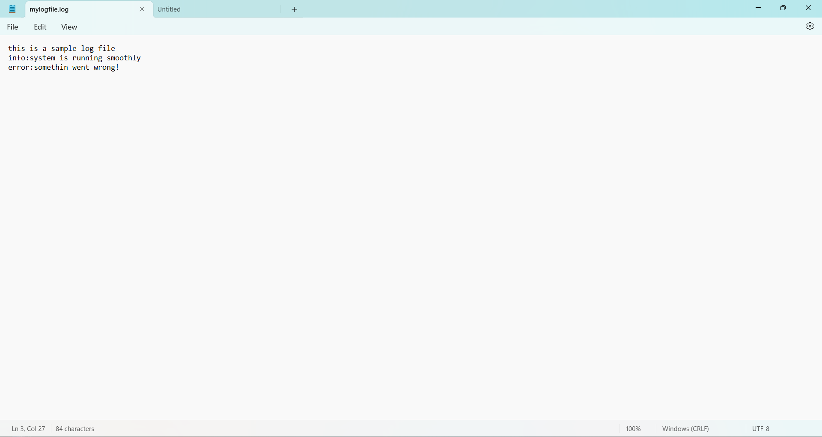

**Step 3**

Open Notepad and Type the following PowerShell script into it and Set the $LogFilePath address to the mylogfile.log which you saved in logs folder. Save the file as monitor_logs.ps1 inside the same logs folder

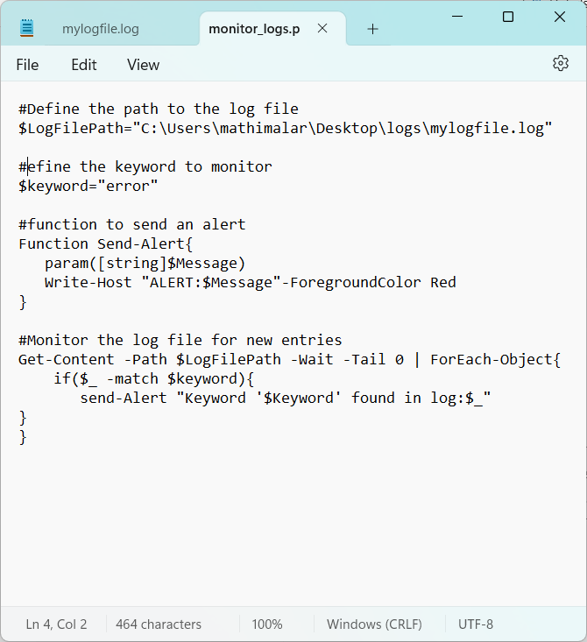

**Step 4:**

Click the Windows Key and Search for Windows PowerShell and click Run as Administrator.

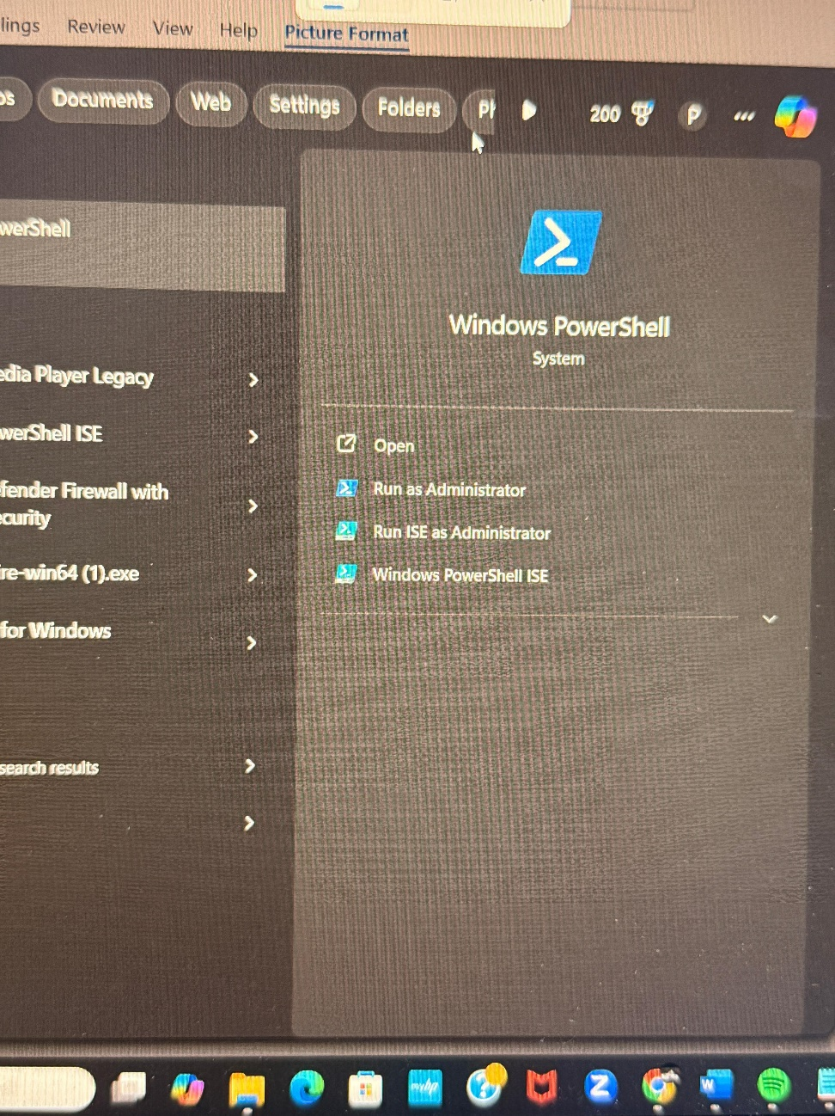

**Step 5:** Run the following command to allow script execution:

Set-ExecutionPolicy -Scope CurrentUser -ExecutionPolicy RemoteSigned

When prompted, type Y and press Enter.

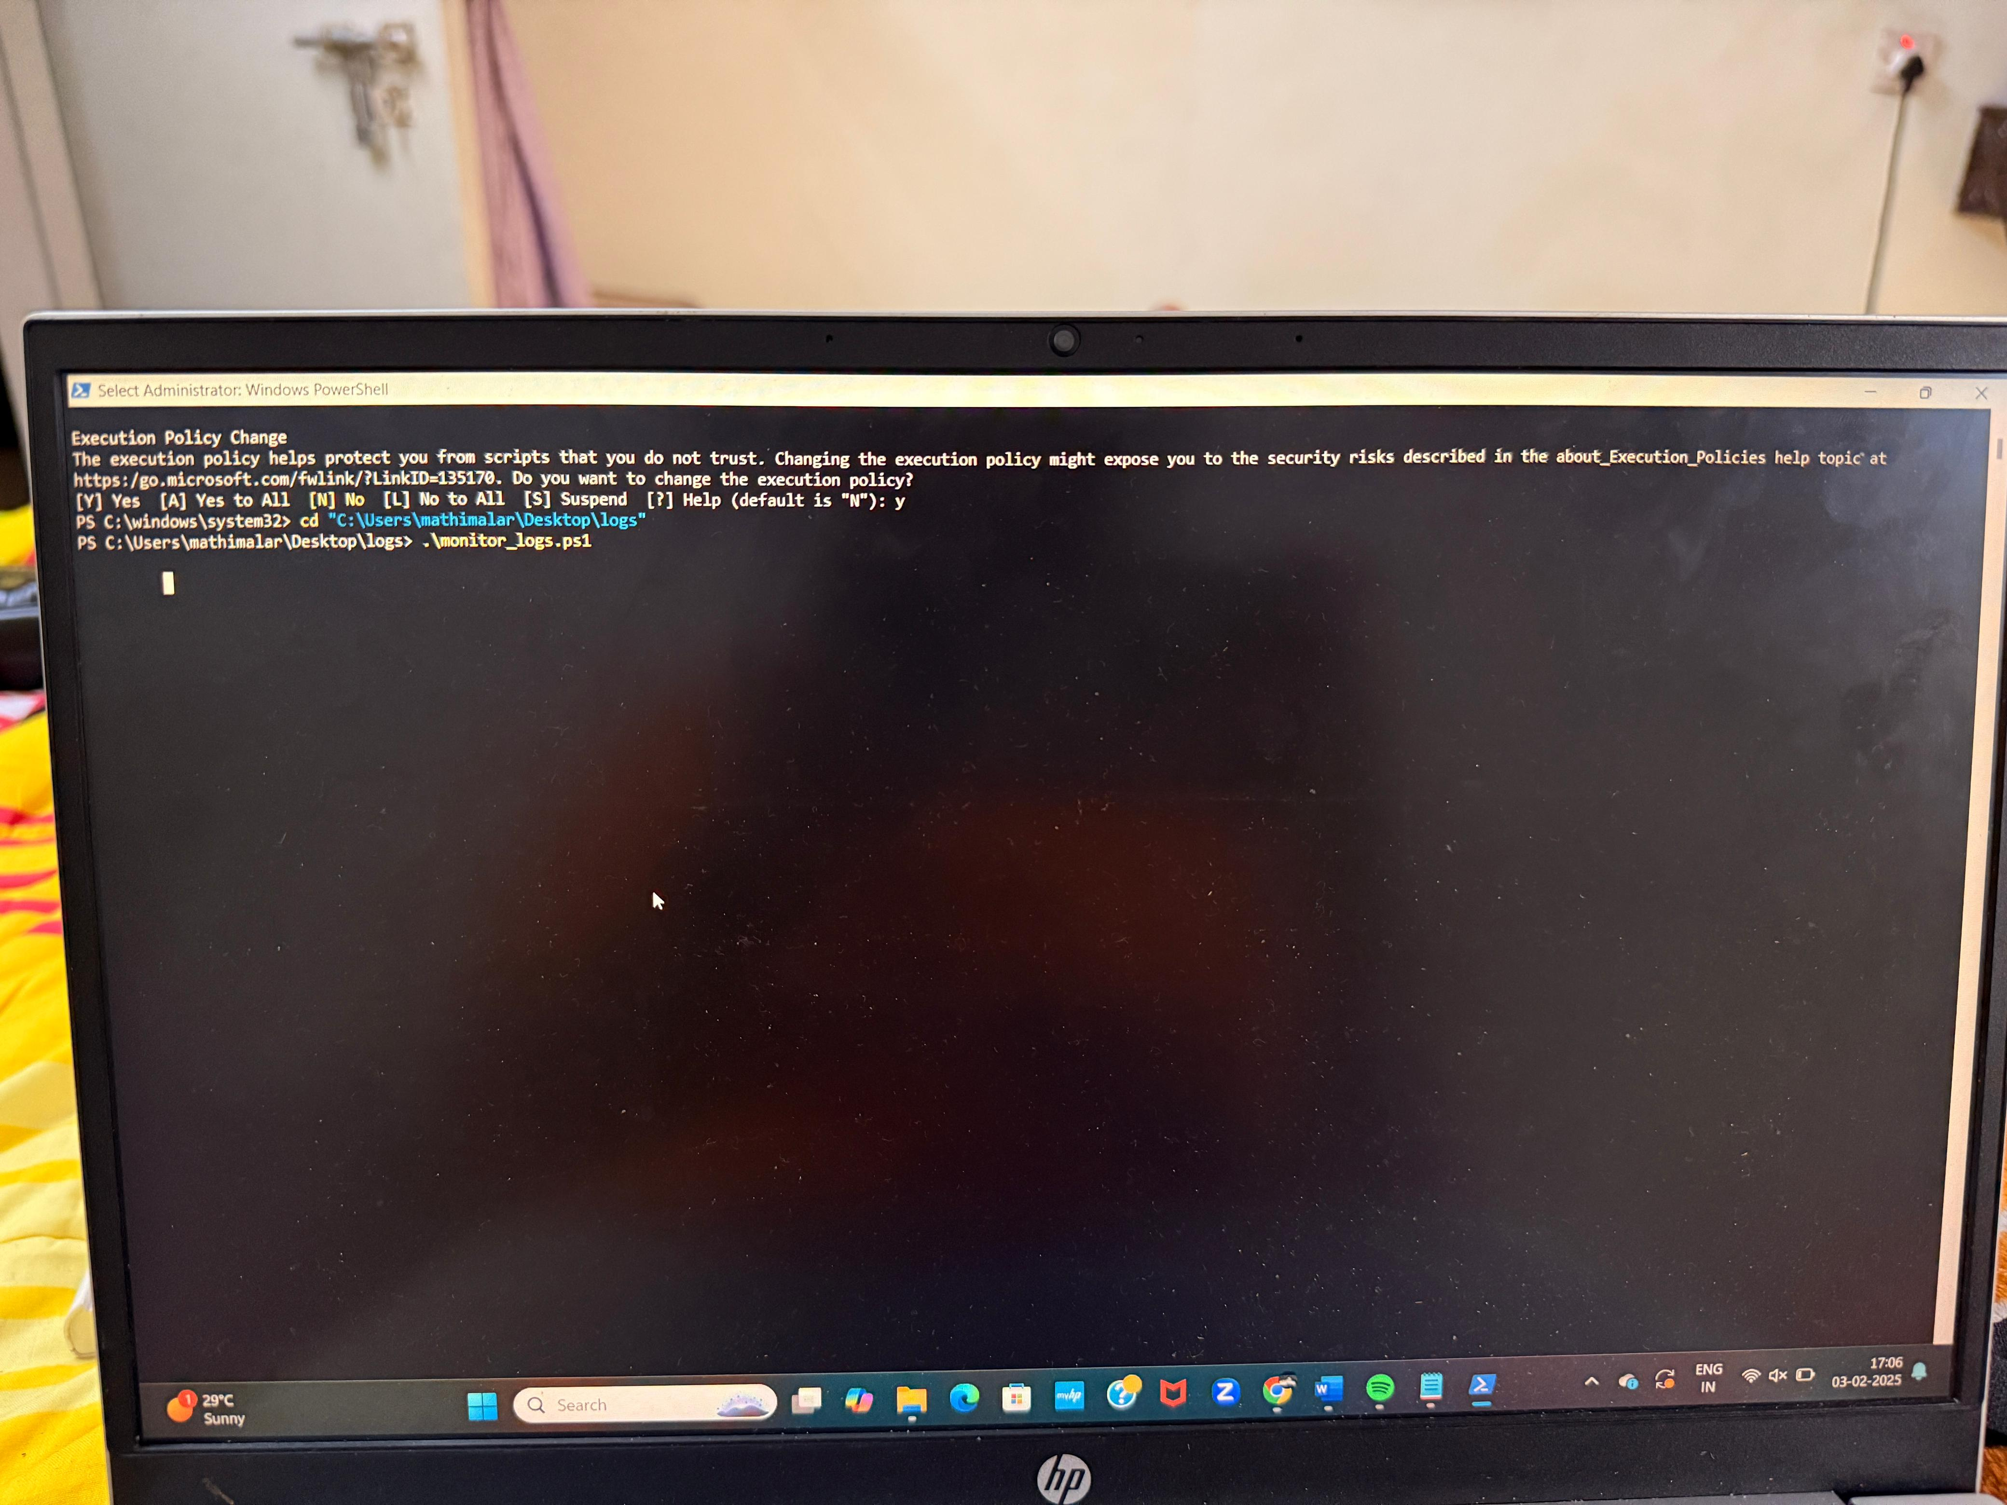

**Step 6: Navigate to the logs folder**



**Step 7:**

Run the script:

.\monitor_logs.ps1



**Step 8** Open mylogfile.log in Notepad and Add a new line with the word "error" and Save the file.

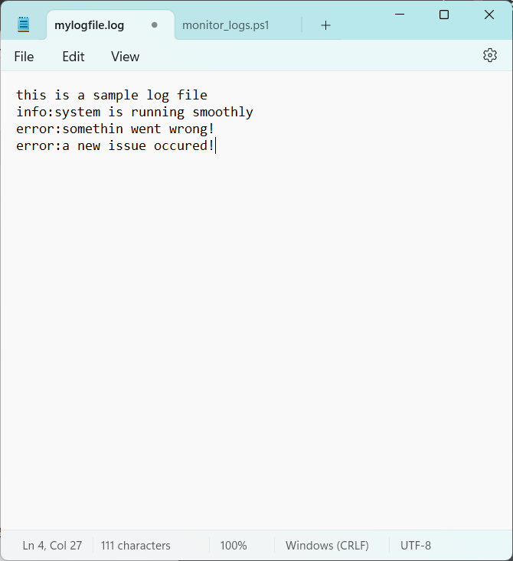

**Step 9:** Check PowerShell — you should see an alert like: ALERT: Keyword 'error' found in log: error: A new issue occurred

**Expected Outcome**

The script successfully enhances log monitoring by automating error detection and alerting. It reduces manual effort, ensuring timely responses to critical issues. With this solution, system administrators can quickly identify and mitigate potential risks, leading to improved system stability and security.